1. Evidence of this is all over countless pages of our history  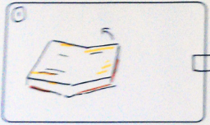  interaction: hands flick over pages of a book  graphics: book image  sound: book flicking pages | 2. From the minutes that ticks and the hours that pass  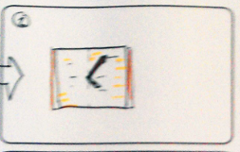  interaction: none, animation only  graphics:book and clock hands  sound: clock sounds | 3. the way some of us may decide to drink tea than the usual coffee... 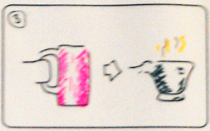  interaction: cup is stuck to hand and flicks to mug  graphics: coffee mug, tea cup  sound: coffee perculator
4. ...we have every morning  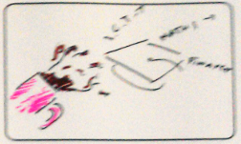  interaction: coffee from the mug is thrown into the air. Drops turn into words  graphics: coffee drops and schooly words  sound: pitch goes as stretched, not cartoony, creaking rope being overstretched, rope bridge | 5. Or the life changing, like the way some us decides on which subjects to take for higher education  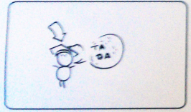  interaction: mortar board lands on the speakers head  graphics: mortar board sound: dropping swanny whistle plus 'pop' | 6. whole community your part of, possibly the whole country, or even the whole world itself.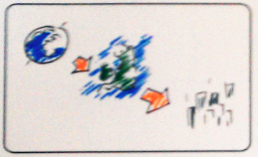  interaction: distance of hands from one another control zoom from image of the world, fading to country to city  graphics: 3 levels of map = world, country, city  sound: digital motor zooming sound
7. An example would be how we decide as a nation which person we choose to lead our country every four years.  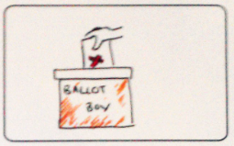  interaction: performer places their vote in a ballot box  graphics: ballot box, vote card with large 'x'  sound: paper scraping | 8. We have the power in our hands  interaction: performer holds glowing orb between her hands  graphics: glowing orb  sound: ? | 9. what if i turned something?  interaction: performer spins image from right to wrong  graphics: images representing right or wrong  sound: ?
10. What if touched somethign that shouldn’t be touched  interaction: peformer touches image which shatters and drops  graphics: image of something that shouldn’t be touched  sound: ? | 11. there will always be one question  interaction: performer brings down theatrical set with both hands dropping  graphics: theatre set  sound: ?

